**Assignment 7.2**

Data set is about Olympics

**Creation of Table in Hive and Loading of data**

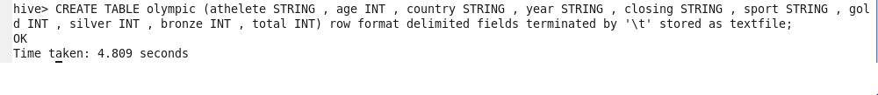

Successfully created **Olympic** hive table

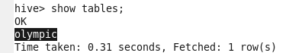

Loading data local inpath



**Problem Statement 1:**

Write a hive program to find the number of medals won by each country in Swimming.

**Select country, SUM (total) from Olympic where sport = “swimming” GROUP BY country;**

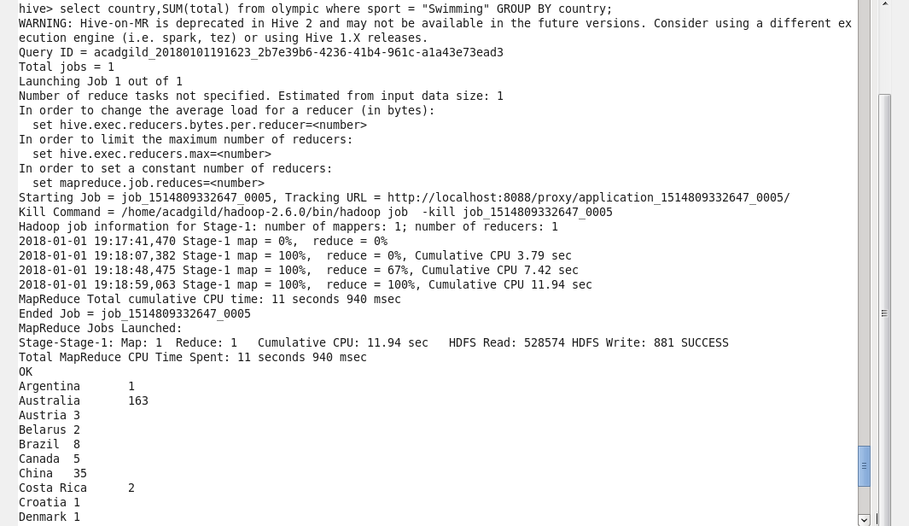

**Problem Statement 2:**

Write a hive program to find the number of medals that India won year wise.

**Select year, SUM (total) from olympic where country = “India” GROUP By year;**

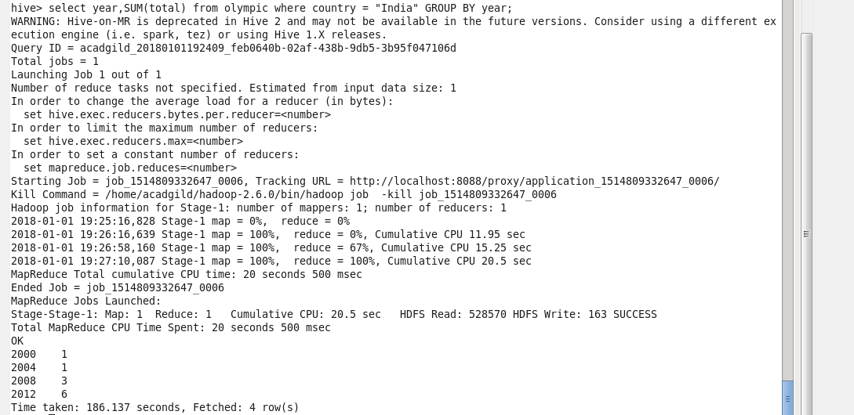

**Problem Statement 3:**

Write a hive program to find the total number of medals each country won.

**Select country, SUM (total) from Olympic GROUP BY country;**

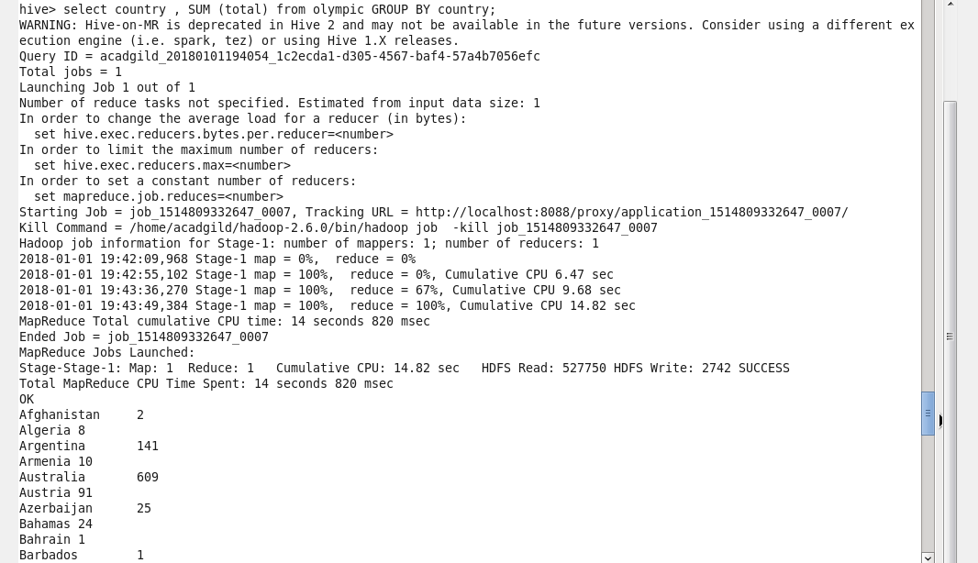

**Problem Statement 4:**

Write a hive program to find the number of gold medals each country won.

**Select country, SUM (gold) from Olympic GROUP BY country;**

